Height Control System

Talaria IV is a canard configured submerged foil hydrofoil with its steering and flying height controlled by to bow strut and foil. From its first flight in 1992 to 2008 it utilized for height control, a mechanical surface follower. A surface skimming plate was projected forward from the bow strut 3 feet using a four bar linkage. It was attached to the bow foil, changing its angle of attack as a function of the boat’s height above the water surface. The mechanism’s feedback was set at .1 radian foil angle per foot of height variation. Via the four bar linkage the angle of the skimmer plate varied with height. When the skimmer was piercing the upper portion of a steep wave its angle was small causing the skimmer to pierce the wave rather than ride over it. This caused the boat to fly through a steep wave rather than attempting to lift itself over. This feature increases the likelihood that the bow foil will not fly out the far side of a wave, ventilate, and subsequently fall into the next wave. This mechanism performed very well. It was however technologically inconsistent with the boat’s analog computer based roll control system and detracting from the boat’s image. Thus a computer controlled height control system has been installed.

The new or replaced components are the bow strut, digital computer, its software in C++, the control law, ultrasonic height sensors, vertical accelerometer, foil position sensor, RPM sensor, bow foil actuator, servo valve/manifold and electronic interface to the computer.

Bow Strut
Several years ago Tom Speer introduced me to XFOIL, a DOS computational fluid dynamics program, downloadable from the NET. With it a new bow strut was designed.
The leading 9” of its 13” cord is cast of 535 aluminum. The trailing edge, housing the bow foil actuator and linkage, is of fiberglass. The casting pattern included a 1.3% allowance for shrinkage. The resulting casting was within a 10 thousands of the design dimensions.
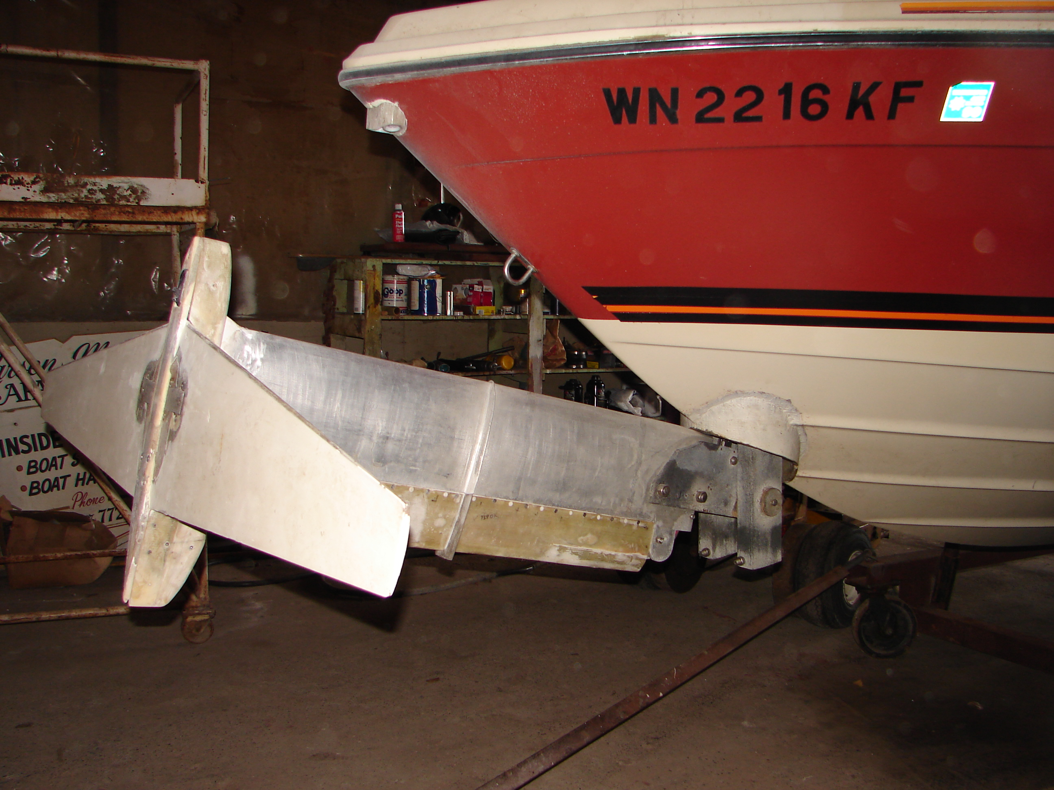

Bow Foil Hydraulics
The bow foil is hydraulically articulated. The hydraulic valve is a Rexroth 4WREPH (Series 3) high performance proportional valve. It opens to 100% in 10 milliseconds and 25% in 5 milliseconds. It is controlled by the computer’s DAC output amplified to a +- 10 volts, using a LM324 amp. It is powered by a 24 volt DC/DC converter. The bow foil is actuated by a 1” ID, 2” throw cylinder milled from 1.25” x 1.5” aluminum and anodized.

Computer and electronic interface
For the digital computer a SBC0489 from Micro/sys was chosen. It has a 133Mhz 486DX class processor, 64M of DRAM, 8 channels of ADC, 1 MB flash memory, 4 channels of DAC, a RS232 interface, VGA screen driver and a floppy disk port. It uses 5 volt power, has no fan, and comes with C++ software examples. An additional 8 ADC channels were added using a PC104 compatible TS9700 from Technologic Systems. While executing the flight control software and displaying the control system’s parameters on a 10 inch flat LCD screen, it updates at 75 Hz. The SBC0489 and MEM sensors are powered by a Wall 25 watt, 5 volt DC/DC converter. The flap position sensors by a Wall +/-15 volt DC/DC converter. The signal conditioning is done with LM324 amps. The screen is a Anrecson 1000 nit 10.4” sunlight readable LCD.

The red square is the TS9700 below it is the SBC0489. In front is the interface circuitry and behind under the SBC0489 are the power supplies.

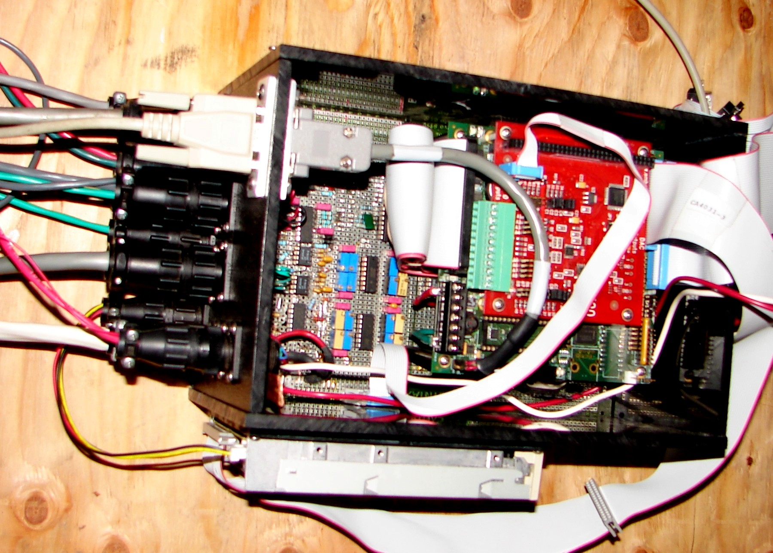

Software
The 1500 lines of source code are in C++. About half are for the display, the rest, the control algorithm and interfacing subroutines. A Borland C++ 5.02 compiler generates the executable code. The executable code is transferred to the SBC0489 flash memory through its floppy drive.
The picture of the screen below is taken with the boat in its cradle. The speed is zero and the control surfaces are near their extreme positions. Zero height is measured from the keel. Flying height is about 12 inches below the keel.
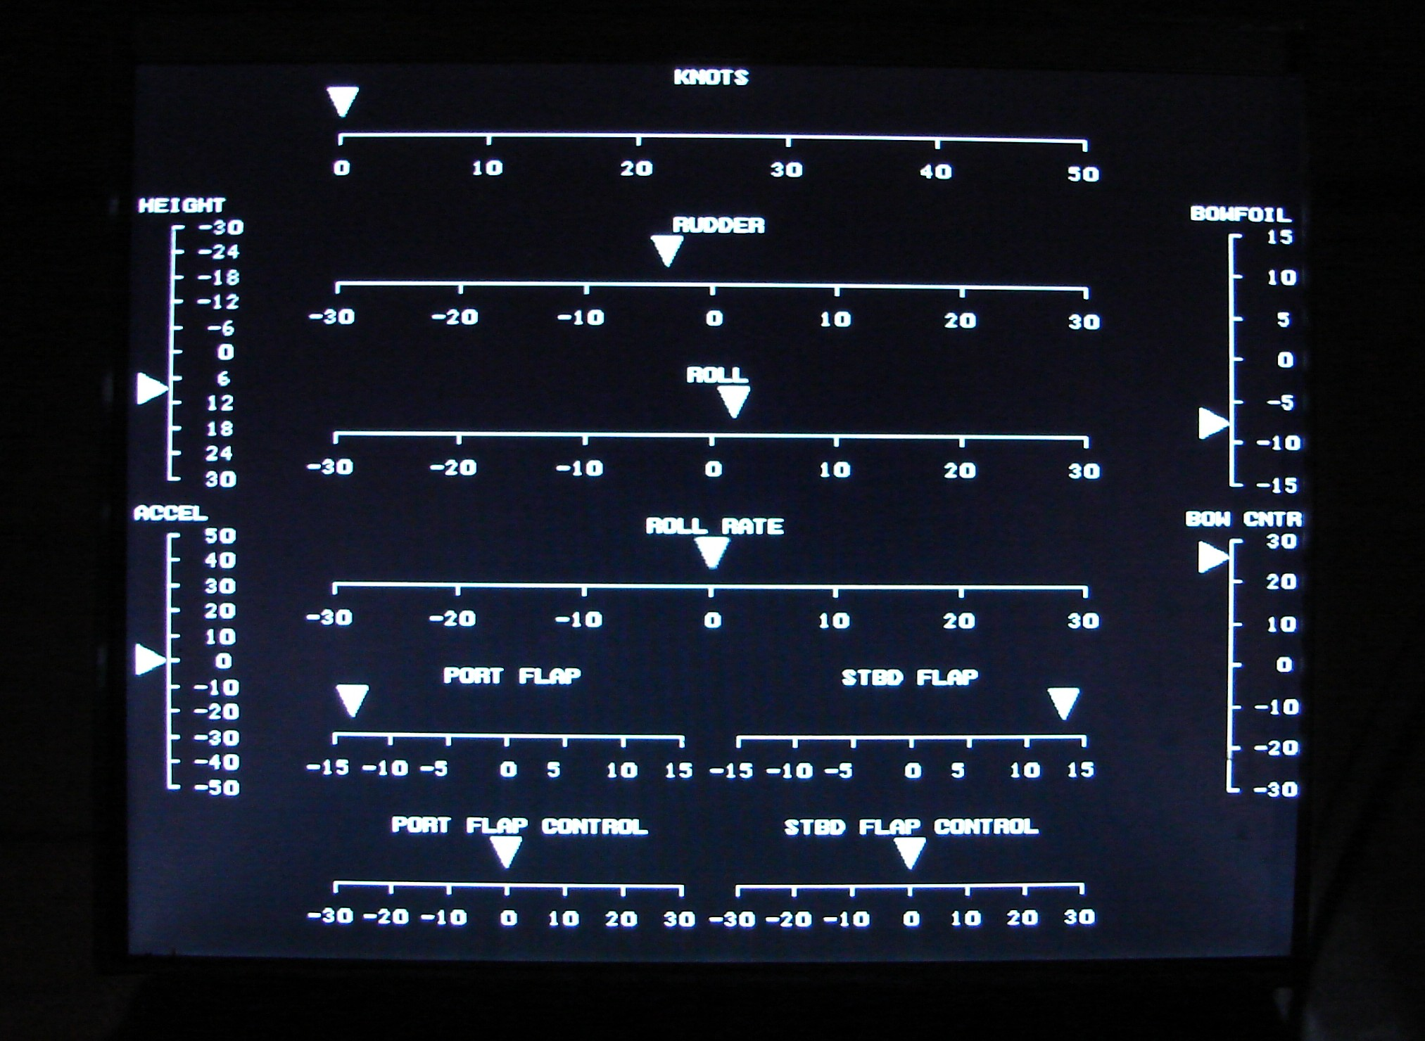

The control law is derived using the Linear Quadratic Regulator algorithm coded in Visual Basic. Its control gains vary with speed.
The differential equation of height is: ddh/ddt = k*(α-(dh/dt)/v) - g, where h = height, α = angle of attack measured from the zero lift angle relative to the boat’s coordinate system, k = the bow foil’s lift slope, g = the gravitational constant, and v = velocity.

Sensors
Talaria’s maximum banking angle is about 20 degrees. Thus a fixed ultrasonic transducer, measuring height, must return a measurement when directed up 20 degrees off axis. The Toughsonic 14 ultrasonic senor by Senix has a 15 degree cone. Two are mounted at the bow splayed apart 15 degrees. They are programmed via an interface to one’s PC to read height alternatively, each at 25 Hz. Thus when both are receiving height signals they sample at 50 Hz. They can be seen in their housing near the gunwale in the bow strut picture.
The accelerometer is an ADXL203, mounted inside the boat’s bow. It uses 5V power and produces a voltage signal.
Because some of the control parameters vary with speed, a knot meter is installed in the aft center strut pod. Its signal is converted via a frequency to voltage converter to a voltage and read by the computer’s ADC. The speed input is also used to adjust the aft foil flaps to maintain the aft foil’s flying height over the speed range. RPM is read similarly and used to set the boat down in case of engine failure.
The replaced mechanical height control mechanism did not have a damper, consequently, when traveling over wavelets, it tended to bounce. The bouncing induced a low frequency vertical vibration at the boat’s bow. With the electronic system the ride is smooth. Also because the height control parameters are speed variable a constant height is maintained across its flying speed range. There is a 7 minute video of Talaria IV produced by Ray Vellinga flying with its new system on YouTube entitled “Hydrofoil Dreamin”.

